Assessment: Assignment 02

Student Name: Harpreet Singh

Lab Professor Name: Syed

Lab Section Number: 343

Due Date: 24/11/2024

# Task 1: Understand the problem

# 

1. Initialize variables

* Created a BatteryChecker object,

1. Create and Evaluate Battery:

• Instantiate a new battery object using the input dimensions.**,**Use the battery checker object to call checkwithintolereance() on the created battery.

•

**4**.Getting Battery Dimensions and tolerances from the user:

* Get the actual diameter and height from the battery object using its getter methods, Use Math.abs() to calculate the absolute difference

1. Check Against Tolerance:

* Compare the absolute differences with the predefined tolerances, checkWithinTolerance() ensures batteries meet the required specifications

**6.** Return Result:

* Return true if both diameter and height are within tolerance; otherwise, return false

# 

# Task 2-1: Detailed UML Class Diagrams

1. Battery

1. Driver

1. Battery Checker

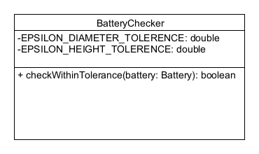

1. User

# Task 2-2: Flowcharts

# Task 3: Test Algorithm with Simple Inputs

## Table 1: Test Plan for method main for the repetition structure logic (looping tests)

| Input | Expected Output | Actual Output | Description |
| --- | --- | --- | --- |
| 3.5  10.3  YES | Enter battery dimensions (expected 3.500 for diameter ,10.300 for height)  Enter battery diameter(mm):  Enter battery height(mm):  Battery: diameter 3.50, height 10.30  Battery is within tolerance.  Do you want to enter another battery? (yes/no); | Enter battery dimensions (expected 3.500 for diameter,10.300 for height)  Enter battery diameter(mm):  Enter battery height(mm):  Battery: diameter 3.50, height 10.30  Battery is within tolerance.  Do you want to enter another battery? (yes/no); | A manual analysis of the procedure main flowchart reveals that the   The logic of the program follows the right stages, and it terminates when the user enters yes |
| 3.5  10.3  NO | Enter battery dimensions(expected 3.500 for diameter ,10.300 for height)  Enter battery diameter(mm):  Enter battery height(mm):  Battery: diameter 3.50, height 10.30  Battery is within tolerance.  Do you want to enter another battery? (yes/no);  Number of batteries out of tolerance: 0  PROGRAM BY HARPREET SINGH | Enter battery dimensions(expected 3.500 for diameter ,10.300 for height)  Enter battery diameter(mm):  Enter battery height(mm):  Battery: diameter 3.50, height 10.30  Battery is within tolerance.  Do you want to enter another battery? (yes/no);  Number of batteries out of tolerance: 0  PROGRAM BY HARPREET SINGH | A manual analysis of the procedure main flowchart reveals that the   The logic of the program follows the right stages, and it terminates when the user enters no |
| 3.5  10.3  maybe | Enter battery dimensions(expected 3.500 for diameter ,10.300 for height)  Enter battery diameter(mm):  Enter battery height(mm):  Battery: diameter 3.50, height 10.30  Battery is within tolerance.  Do you want to enter another battery? (yes/no);  Enter battery diameter(mm): | Enter battery dimensions(expected 3.500 for diameter ,10.300 for height)  Enter battery diameter(mm):  Enter battery height(mm):  Battery: diameter 3.50, height 10.30  Battery is within tolerance.  Do you want to enter another battery? (yes/no);  Enter battery diameter(mm): | A manual analysis of the procedure main flowchart reveals that the   The logic of the program follows the right stages, and it terminates when the user enters maybe |

## Table 2: Test Plan for method main for verifying the battery tolerance check.

Reminder: Highlight in your testing table the relevant items you are testing and validating, as shown in the sample.

|  |  |  |  |
| --- | --- | --- | --- |
| Input  3.33333333  10.300000000  no | Expected Output  Enter battery dimensions(expected 3.500 for diameter ,10.300 for height)  Enter battery diameter(mm):  Enter battery height(mm):  Battery: diameter 3.33, height 10.30  Battery is out of tolerance.  Do you want to enter another battery? (yes/no);  Number of batteries out of tolerance: 1  PROGRAM BY HARPREET SINGH | Actual Output  Enter battery dimensions(expected 3.500 for diameter ,10.300 for height)  Enter battery diameter(mm):  Enter battery height(mm):  Battery: diameter 3.33, height 10.30  Battery is out of tolerance.  Do you want to enter another battery? (yes/no);  Number of batteries out of tolerance: 1  PROGRAM BY HARPREET SINGH | Description  Using a hand trace of the flowchart of the checkWithinTolerance method of class BatteryChecker for diameter below tolerance is functioning correctly as the difference is 0.1666667. and it terminates when the user enters no. |
| 3.2  10.3  no | Enter battery dimensions(expected 3.500 for diameter ,10.300 for height)  Enter battery diameter(mm):  Enter battery height(mm):  Battery: diameter 3.20, height 10.30  Battery is out of tolerance.  Do you want to enter another battery? (yes/no);  Number of batteries out of tolerance: 1  PROGRAM BY HARPREET SINGH | Enter battery dimensions(expected 3.500 for diameter ,10.300 for height)  Enter battery diameter(mm):  Enter battery height(mm):  Battery: diameter 3.20, height 10.30  Battery is out of tolerance.  Do you want to enter another battery? (yes/no);  Number of batteries out of tolerance: 1  PROGRAM BY HARPREET SINGH | Using a hand trace of the flowchart of the checkWithinTolerance method of class BatteryChecker for diameter below tolerance is functioning correctly as the difference is 0.3. and it terminates when the user enters no. |
| 4  10.3  no | Enter battery dimensions(expected 3.500 for diameter ,10.300 for height)  Enter battery diameter(mm):  Enter battery height(mm):  Battery: diameter 4.00, height 10.30  Battery is out of tolerance.  Do you want to enter another battery? (yes/no);no  Number of batteries out of tolerance: 1  PROGRAM BY HARPREET SINGH | Enter battery dimensions(expected 3.500 for diameter ,10.300 for height)  Enter battery diameter(mm):  Enter battery height(mm):  Battery: diameter 4.00, height 10.30  Battery is out of tolerance.  Do you want to enter another battery? (yes/no);no  Number of batteries out of tolerance: 1  PROGRAM BY HARPREET SINGH | Using a hand trace of the flowchart of the checkWithinTolerance method of class BatteryChecker for diameter below tolerance is functioning correctly as the difference is 0.5 . and it terminates when the user enters no. |
| 3.4  10.25  Yes  3.1  10.2  no | Enter battery dimensions(expected 3.500 for diameter ,10.300 for height)  Enter battery diameter(mm):  Enter battery height(mm):  Battery: diameter 3.40, height 10.25  Battery is out of tolerance.  Do you want to enter another battery? (yes/no);  Enter battery diameter(mm):  Enter battery height(mm):  Battery: diameter 3.10, height 10.20  Battery is out of tolerance.  Do you want to enter another battery? (yes/no);  Number of batteries out of tolerance: 2  PROGRAM BY HARPREET SINGH | Enter battery dimensions(expected 3.500 for diameter ,10.300 for height)  Enter battery diameter(mm):  Enter battery height(mm):  Battery: diameter 3.40, height 10.25  Battery is out of tolerance.  Do you want to enter another battery? (yes/no);  Enter battery diameter(mm):  Enter battery height(mm):  Battery: diameter 3.10, height 10.20  Battery is out of tolerance.  Do you want to enter another battery? (yes/no);  Number of batteries out of tolerance: 2  PROGRAM BY HARPREET SINGH | Using a hand trace of the flowchart of the checkWithinTolerance method of class BatteryChecker for diameter below tolerance is functioning correctly as the difference is 0.1, 0.4. And it terminates when the user enters no. |
| -3.555  10.300  No | Enter battery dimensions(expected 3.500 for diameter ,10.300 for height)  Enter battery diameter(mm):  Enter battery height(mm):  Battery: diameter -3.56, height 10.30  Battery is out of tolerance.  Do you want to enter another battery? (yes/no);  Number of batteries out of tolerance: 1  PROGRAM BY HARPREET SINGH | Enter battery dimensions(expected 3.500 for diameter ,10.300 for height)  Enter battery diameter(mm):  Enter battery height(mm):  Battery: diameter -3.56, height 10.30  Battery is out of tolerance.  Do you want to enter another battery? (yes/no);  Number of batteries out of tolerance: 1  PROGRAM BY HARPREET SINGH | Using a hand trace of the flowchart of the checkWithinTolerance method of class BatteryChecker for negative diameter is functioning correctly as the difference is 7.000. and it terminates when the user enters no. |

## 

# Task 5: Five screenshots of validating the Algorithm Test Table

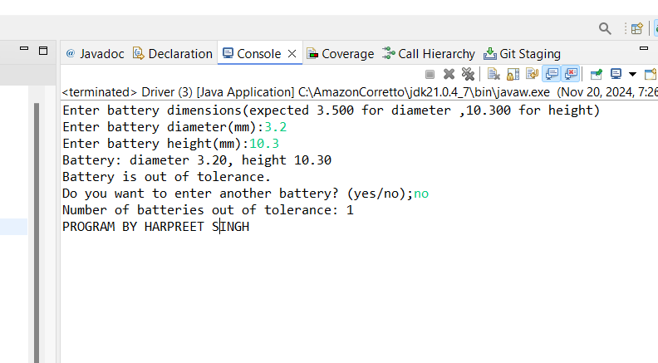

# References